Status Update 14.07.20

The authors from iDLG did a good improvement for DLG by including label prediction from gradients in their recreation setup. Their prediction method works 100% in batch size 1 scenarios. For other batchsizes it is not defined. Instead they changed the scenario and said the victim should just send them the gradients from each individual sample of a batch, just lika in a batch size 1 scenario.

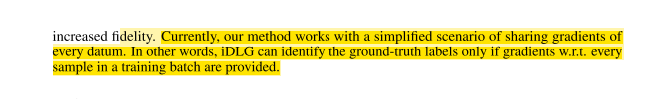
I try to develop a prediction strategie, that might not reach the 100% prediction rate, but that doesn’t cheat the scenario like they did.

Their approach is to take the second last layer of gradients and find the negative value, which they logg in as their prediction candidate.
Starting with a randomly generated sample they alter it in order to optimize the result. To archieve this, they minimize the difference between the originally attacked gradients and the gradients, the network produces when the dummy is inserted and the weights get fitted toward the predicted output.
For batch sizes larger than 1 the predicted gradient values start to overlay each other. However it is still possible to predict the labels. Even though negative values might become positive in this overlayed state and the result gets more blurry. Negative values hint the classes and the magnitude of the values hints how often a value is present in the batch.

For example: the following classes [2, 2, 2, 5, 7, 8] produced this batch
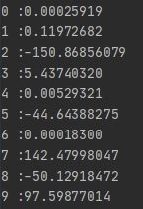

My first draft for a prediction strategie will proceed in two steps. Step one is to take every negative value. These are pretty likely to be present in the original batch. In this case [2, 5, 8]. That means 5 more values to predict. In order to get a feeling for the impact one occurance of a class makes, I take the negative values add them together and devide the result by the batchsize. In this case about -40.
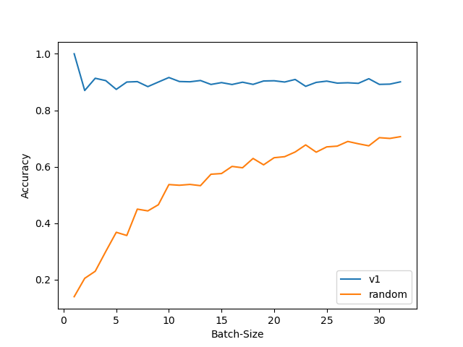
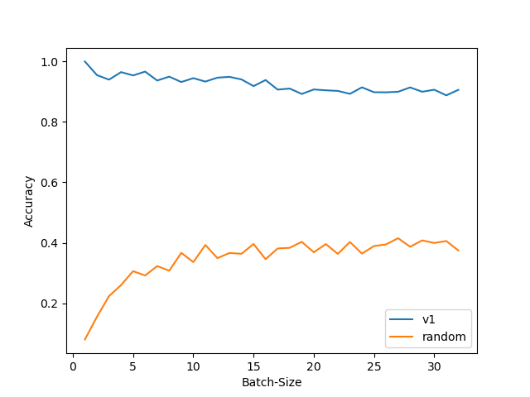
So fore the next prediction step I choose the smallest value, add it to my prediction and reduce its value by the mean value unitl my prediction list reaches the size of the batch.
Biased Data: 50% [0], 25% [1], 25% random [2-9]
IID IID Data

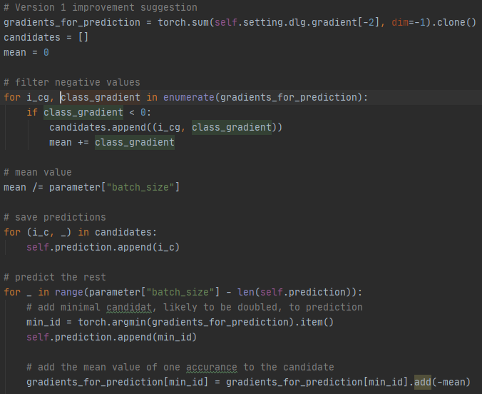
Code for my prediction:

In my example the algorithm suggests:
[2, 2, 2, 2, 5, 8,]
instead of the original
[2, 2, 2, 5, 7, 8]

5/6 Accuracy is pretty decent. As the following graph suggests, this holds for larger batch sizes.
Here you can see a graph off accuracy versus batchsizes [1, 32]. average of 100 runs .

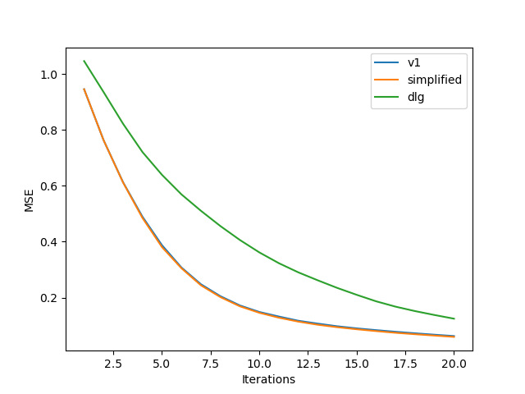
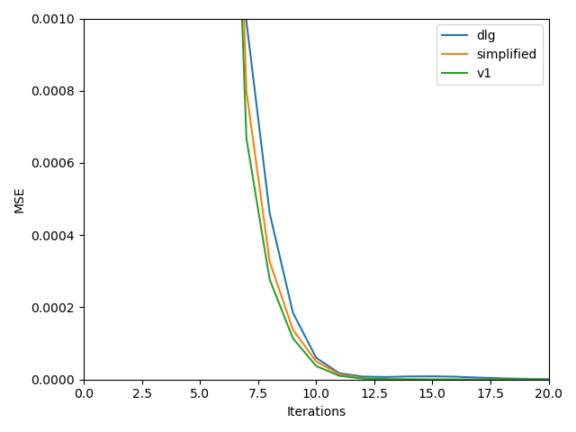
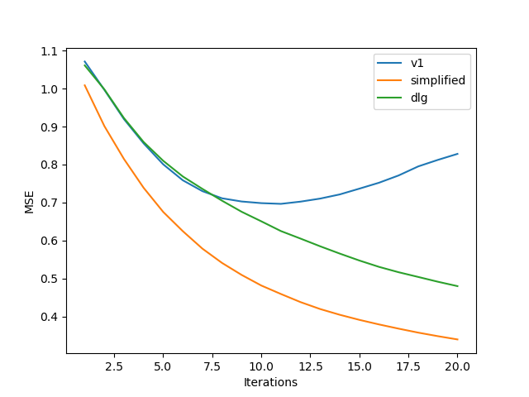
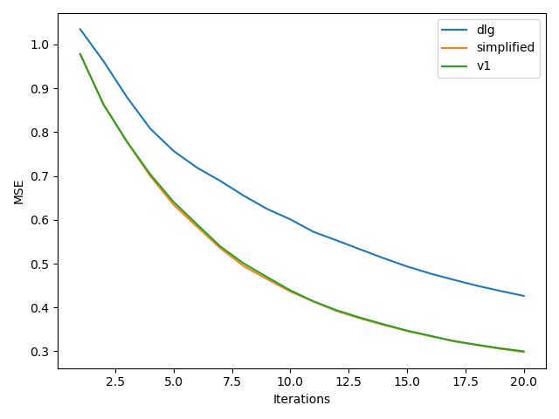
However, as you can see, the class 7 occurrence in the original batch, for some reason caused a huge positive value. There is for sure room for improvement of this strategie. I currently have the following ideas:
BS 4
BS 1
BS 1
BS 8
BS 8
Prefect prediction
- Include absolute value of the gradients
- Create multiple fake batches first, so that the attacker can calculate the mean value from that more precisely.
- Create multiple fake batches, train a neural network to predict classes from the fakes and then use the network for our prediction task

But before I work more on these additional strategies I have to evaluate the reconstructed images first, because this is the whole point of the task anyway.
My 90% prediction + iDLG won’t be as good as the 100% (cheated) prediction + iDLG from the paper. The interesting part is, whether it can beat the traditional DLG without bending the scenario.

On my machine it takes a very long time to run the image recreations. For a comprehensive study I’d have to run the recreation for different batch sizes and for different strategies several time to get average values while I adapt my strategies. Maybe we can get on a computer cluster for this task.

I did some test runs:
For bs = 1 there is almost no difference between the strategies
For small batchsizes bs=4 my algorithm has as good performance as the idlg, which is better than dlg.
For larger batchsizes bs =8 my algorithm starts to make prediction mistakes, which result in higher recreation error. However the runs where the prediction went perfect let to good results

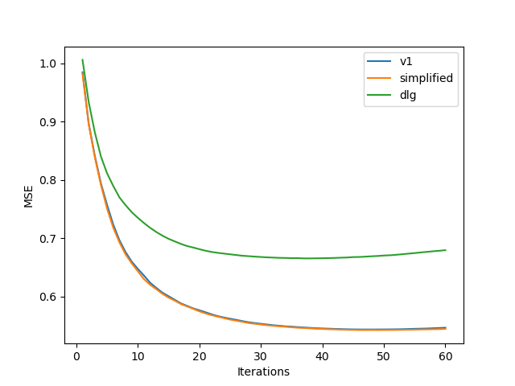
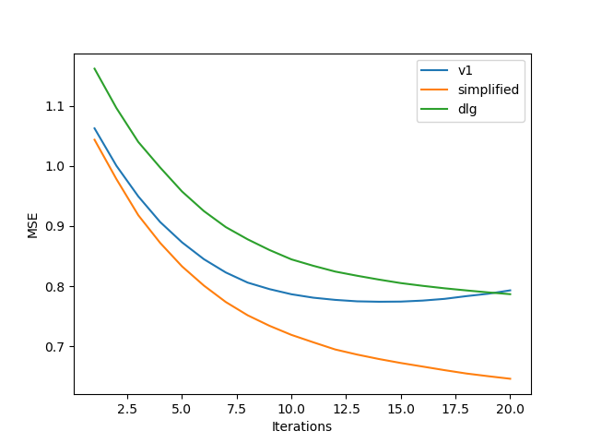
I got the same results at bs16
BS 16
BS 16
Perfect prediction

In this run the prediction got 1/16 labels wrong and did not converge.

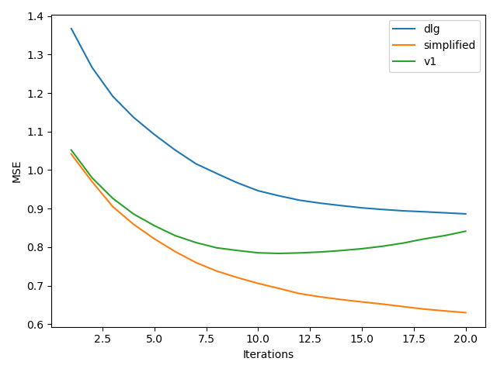

So we can see even 1 mistake makes v1 perform worse.

One interesting aspect might be to have a look on how likely it is to get a perfect prediction.
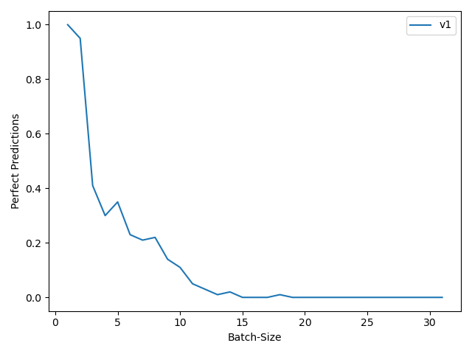
Unfortunatly this is worse than I expected.
Status Update 24.07.20

In order to analyse, where the fail predictions come from I took a look on the gradients.
Here we see the gradients, the accuracy and the predictions for bs 1 to 32:
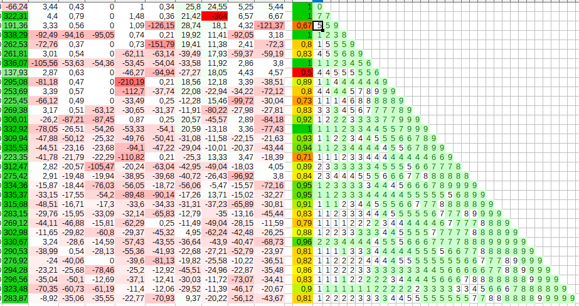
As we see class 0 gradients are higher by several magnitudes than other gradients.
I tried to understand where this comes from and found. That in other runs there is always one or two classes that shows this behaviour. Just look at the colors:
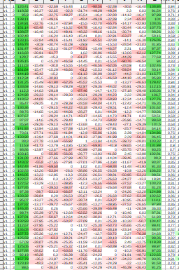

In a case, where class 0 was effected the prediction never choose 0 (apart from bs1) because the value was to high. Cases including zeroes in the original batch caused a reduction on the 0-gradient. However it is still to high, to be included in the prediction.

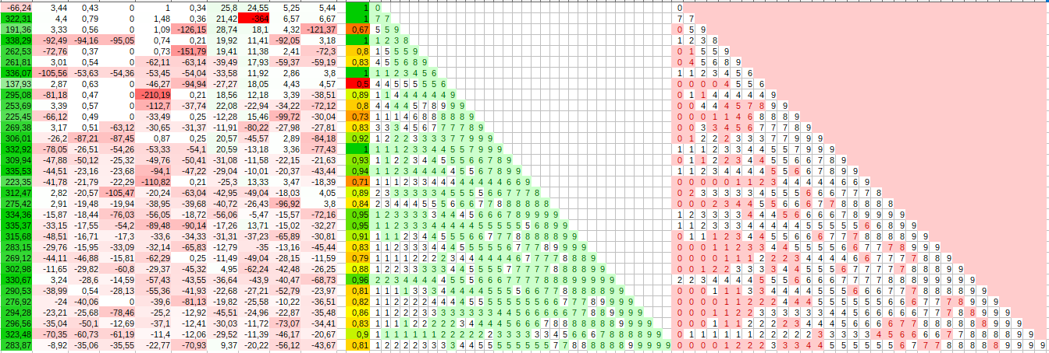
This effect was caused, because I initialized the networks weights randomly at the beginning and used it for the complete run. When I reinitialized weights between each prediction the effect effected a random class each run.

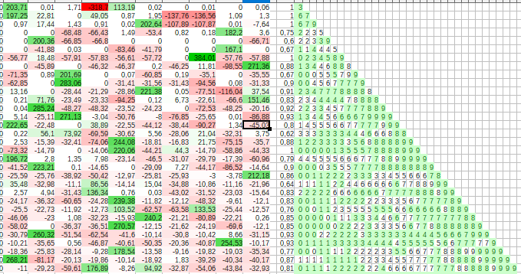
So the effect is specific to the current weights of the network. I call this effect net bias for now.

The netbias disturbs the prediction, so I tried to figgure out how to get arround this.
I tried to calculate the networks bias by feeding it 100 random images from the dataset and get the mean gradients from that. This should show the bias of the current gradients.
Further I updated the way I calculate the “mean” value that is added to one of the gradietns between each prediction step. In the code it is called impact. I calculate it by analysing a batch with only 0 samples in it. The gradient at the position zero indicates the value drop, that was caused by the zeros.
Divided by the batchsize we have a good value for the value we should add each step.
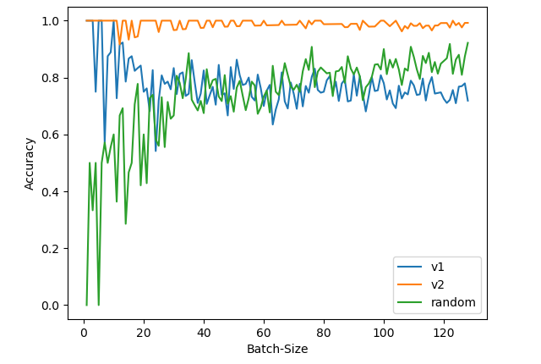

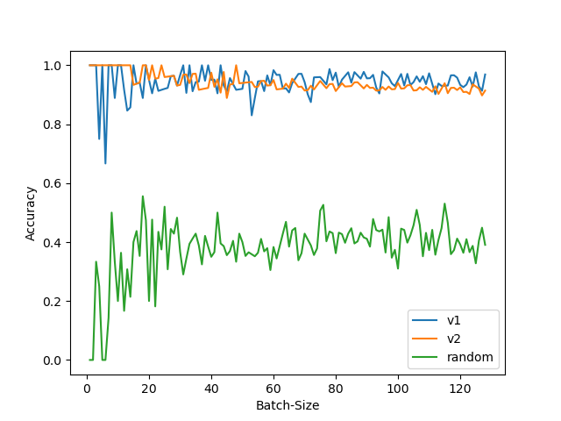
The method profits from the iid data. It is weaker on biased data.

From looking at the raw gradients I saw, that it got problems, when a certain class apears to often. Probably the mean calculation is a little bit off. If it gets added several times this adds up. The biased data featerd 50% 0-digits, so this effect was pretty heavy. To be precisely it predicted the 0 to likely, so that there were always a few zeroes more in the prediction than in the ground truth.

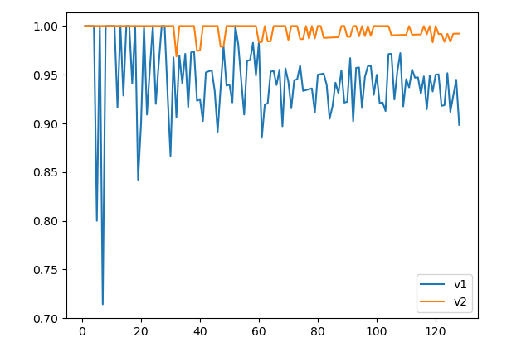
I expected the mean value to be a little bit to low, so it will sometimes predict the often appearing labels to likely. That means I just had to increase the value a little bit. I added 10% to the impact and again improved my results

